Computer Control for High Functionality
of Industrial Machinery
○○ University △△ Graduate School □□ Engineering
Taro Yamada*

- Introduction

In recent years, labor shortages have become a problem due to the declining birthrate and aging population, and the labor force is supplemented using industrial machinery. .. .. .. Therefore, in order to deal with this problem, it is essential to increase the speed and functionality of industrial machines ¹⁾. In this research, we designed a computer for motion control for the purpose of improving the functionality of industrial machines.

2. High functionality and issues of industrial machinery

Here, we will first introduce the issues for improving the functionality of industrial machinery. ・ ・ ・ ・ ・ ・ Therefore, in order to realize high functionality of industrial machines, it is necessary to solve the problems inherent in computers.

- Motion control computer design

In this research, we designed a control computer. ・ ・ ・ ・ ・ ・
The controller was configured as shown in Fig. 1.

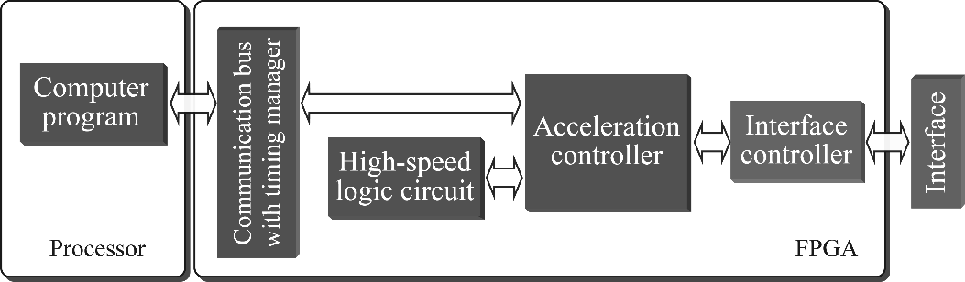

Figure 1. Structure of SoC FPGA paste control system

9. Summary

In this research, we designed a computer for motion control for the purpose of improving the functionality of the machine. Through experiments, it was shown that the designed controller ensures high motion control performance and can realize functional motion by utilizing computational resources for intelligence.

Acknowledgments

We received a great deal of support from △△ in carrying out this research. I would like to express my gratitude here.

References

1) Fujimoto, T. Murakami, and R. Oboe, “Advanced motion control for next-generation industrial applications”, IEEE Transactions on Industrial Electronics, vol. 63, no. 3, pp. 1886–1888, 2016.
2) Hiroki Kurumatani and Seiichiro Katsura, “Robot Control with Wideband Acceleration Control Embedded on Programmable SoC”, The 45th Annual Conference of IEEE Industrial Electronics Society, IECON2019-LISBON, Lisbon, Portugal, pp. 5198–5203, October 2019.
3) S.D. Eppinger and W.P. Seering, “Three dynamic problems in robot force control”, IEEE Transactions on Robotics and Automation, vol. 8, no. 6, pp. 751–758, December 1992.
4) The method of quoting documents is based on the relevant academic journals. ・ ・ ・

